Submitted by : Thanuj Kumar S

practice : basic process management

1. Use ps to search for the init process by name.



1. What is the process id of the init process ?

1

1. Use the who am i command to determine your terminal name.



1. Using your terminal name from above, use ps to find all processes associated with your terminal.

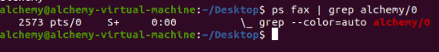

1. What is the process id of your shell ?



1. What is the parent process id of your shell ?

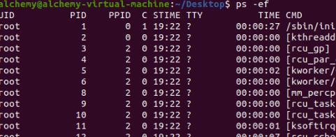

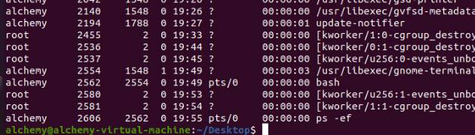

1. Start two instances of the sleep 3342 in background.

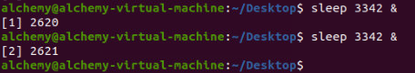

1. Locate the process id of all sleep commands.



1. Display only those two sleep processes in top. Then quit top.

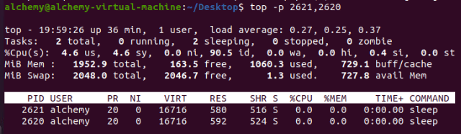

1. Use a standard kill to kill one of the sleep processes.



1. Use one command to kill all sleep processes

# practice : process priorities

1. Create a new directory and create six pipes in that directory.



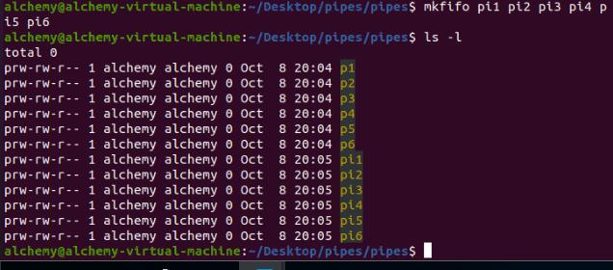

1. Bounce a character between two pipes.

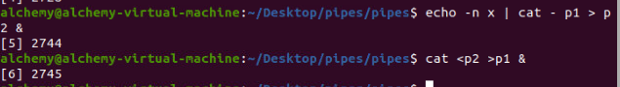

1. Use top and ps to display information (pid, ppid, priority, nice value, ...) about these twocat processes.

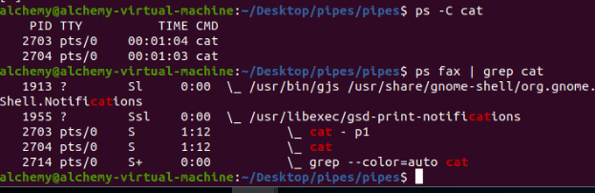

1. Bounce another character between two other pipes, but this time start the commands nice.

Verify that all cat processes are battling for the cpu. (Feel free to fire up two more cats withthe remaining pipes).

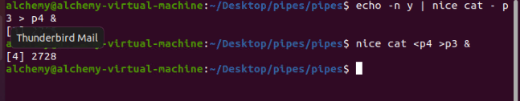

1. Use ps to verify that the two new cat processes have a nice value. Use the -o and -C options of ps for this.

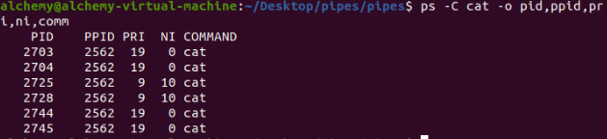

1. Use renice te increase the nice value from 10 to 15. Notice the difference with the usual commands.

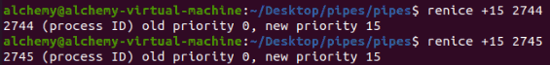

# practice : background processes

1. Use the jobs command to verify whether you have any processes running in background.

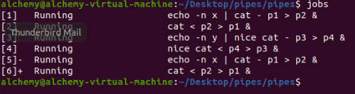

1. Use vi to create a little text file. Suspend vi in background.



1. Verify with jobs that vi is suspended in background.

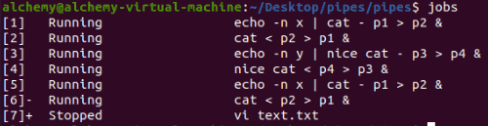

1. Start find / > allfiles.txt 2>/dev/null in foreground. Suspend it in background before it finishes.

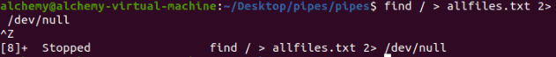

1. Start two long sleep processes in background.

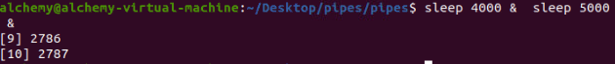

1. Display all jobs in background.

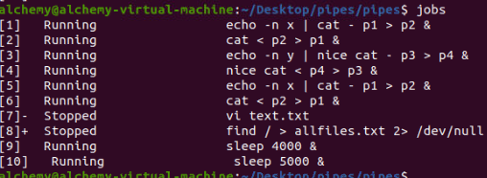

1. Use the kill command to suspend the last sleep process.



1. Continue the find process in background (make sure it runs again).

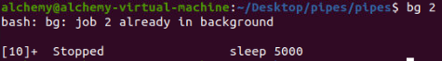

1. Put one of the sleep commands back in foreground.

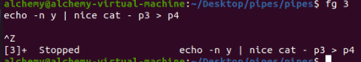

Submitted by Thanuj Kumar S